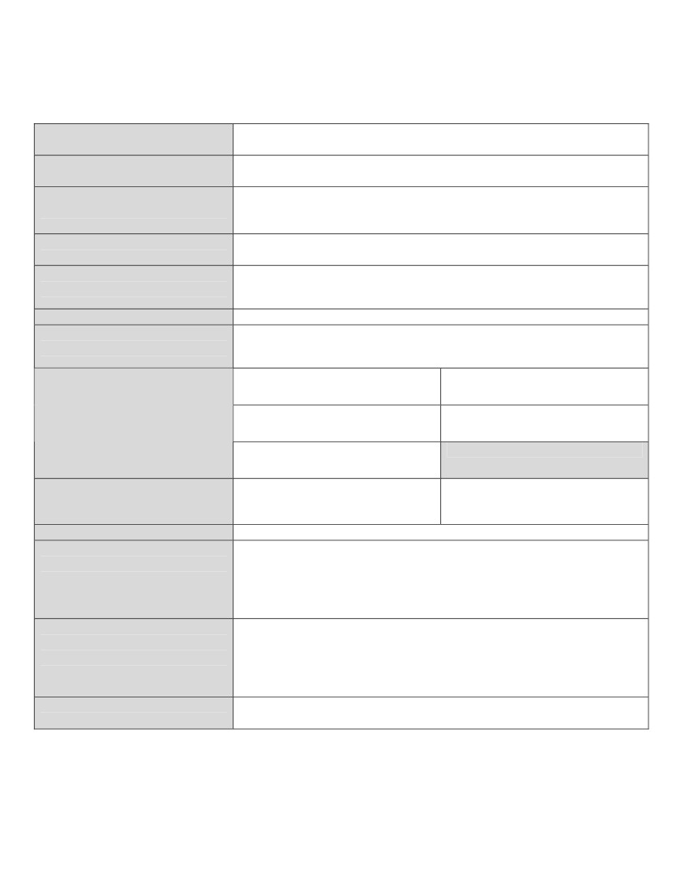
SPECIAL DISTRICT TRANSPARENCY NOTICE - 2017
Pursuant to Section 32-1-809, Colorado Revised Statutes
This information must be provided1 to the eligible electors of the District no later than January 15th
Name of special district
Address:
Name and telephone number of
manager or other primary contact
person for district
Time and place designated for
regular board meetings
Posting place designated for
meeting notice
(as per §24-6-402(2)(c), C.R.S.)
Kiowa Fire Protection District
403 County Road 45
P.O. Box 321, Kiowa, CO 80117(303)621-2233
Fire Chief: Gerald Lamansky – (303)621-2233
Administrative/Finance Officer: Geri Scheidt – (303)243-0833
Kiowa Fire Station #1 Start Time: 7:00 PM – 2nd
403 County Road 45, Kiowa, CO 80117 Wednesday of Every Month
Elbert County Courthouse, Kiowa Fire Station #1, Kiowa Post Office,
Kiowa Library
8.689 mills for 2017
8.689 mills extended upon an assessed valuation of $29,450,298 for
$255,894 in revenue (unaudited)
(1)Greg Albers Sr., Director
4 year term
This office will be on the May 5, 2020 ballot
District mill levy
Total ad valorem tax revenue
received by district during 2016
(Note if unaudited or otherwise incomplete.)
Names of Board Members
(2) Greg Birkey
2 year term
This office will be on the May 1, 2018 ballot
(3) James H. Jerrold, Chairman
4 year term
This office will be on the May 1,2018 ballot
(4) Martha Ann Alley, Vice Chair
4 year term
This office will be on the May 5, 2020 ballot
(5) Debbie Ullom, Treasurer

4 year term
This office will be on the May 1, 2018 ballot
For seven-member boards:
(6)
(7)
Date of next regular election
Self-nomination forms to be a
candidate for district board
member may be obtained from
May 8, 2018
Name: Geri Scheidt, Kiowa Fire Protection District, 403 County Road
45, P.O. Box 321, Kiowa, CO 80117
Contact information: 303-243-0833 M-F 10:00am – 4:00pm
Self-nomination forms to be a
candidate for district board
member should be returned to
Name: Geri Scheidt, Kiowa Fire Protection District, 403 County Road
45, P.O. Box 321, Kiowa, CO 80117
Contact information: 303-243-0833 M-F 10:00am – 4:00pm
Completed self-nomination forms March 2, 2018 no later than 4:00 p.m.
must be received by the district by
Continued on page 2

District election results will be
posted on these websites:
Applications to request
permanent mail-in voter status
(Enter county or counties in which the district
is wholly or partially located.)
Secretary of State
www.sos.state.co.us
may be obtained from:
Elbert County Clerk & Recorder
or
online from Secretary of State:
www.elections.colorado.gov
Name: Geri Scheidt
Title: Admin/Finance Officer
E-mail:
geri.scheidt@comcast.net
District or other website:
www.kiowafire.com
and may be returned to:
Elbert County Clerk & Recorder
P.O. Box 37, Kiowa, CO 80117
Notice completed by:
Notice Dated: December 15, 2017
Some information herein may be subject to change.
File copy of this Notice with:
Clerk and Recorder of each county in which district is wholly or partially located;
Division of Local Government; and
District’s principal business office (make available for public inspection).
1
Notice must be provided in one or more of the following manners:
a) Mail notice separately to each household where one or more eligible electors of the special district resides (Note: Districts
with overlapping boundaries may combine mailed notices, so long as the information regarding each district is separately
displayed and identified);
b) Include notice as a prominent part of a newsletter, annual report, billing insert, billing statement, letter, voter information
card or other notice of election, or other informational mailing sent by the district to the eligible electors;
c) Post notice on district’s official website (Note: You must also provide the Division of Local Government
(www.dola.state.co.us/dlg) with the address of your district’s website to establish a link on the DLG’s site (use DLG’s Local
Government Contact Information form);
d) Post notice on website of the Special District Association of Colorado (www.sdaco.org) (Note: Your district must be an SDA
member. Send notice to SDA by mail or electronic transmission); or
e) Post notice in at least three public places within the limits of the special district and post notice in the office of the Clerk and
Recorder of the county or counties in which the district is located. Notices must remain posted in these locations until May 4,
2012. (Note: This method for providing notice is only available for districts with less than 1,000 eligible electors that are
wholly located within a county with a population of less than 30,000.)
2

